**ABSTRACT**

1. **ABSTRACT**

Our project is entitled as **eMS – Electronic Messaging Service.** It is like a social media which provides you the online and offline messaging services. We have used PHP as front end and My SQL as backend. The objective is to provide messaging service.

**Modules Required:**

* Home page
* My Profile
* Premium
* Chat with Server
* Maps
* Online Messages
* Offline Messages

**Modules Description: -**

**Home Page:**

* Home page displays about our messaging system.

**Premium:**

* Premium account
* The premium account contains some schemes. E.g. Unlimited messages for one month at Rs. 150
* The money payment is an online money transaction (on process).

**Login:**

* Sign in and sign up form is used to create a new account or to access the existing account.
* The sign-up form includes user name, date of birth, contact number, mail id, etc.
* The login or sign in form asks you for the contact number or mail id and the password of the created account.

**My Profile**

* My profile displays your document picture and other details which you entered during the signup process.
* Our user profile is editable.

**Online messages:**

* Online message module contains the recent chat history.
* User Profile will have displayed.

**Offline message:**

* Offline message service which provides the inbox messaging.
* Free message.

**Contact List:**

* This module shows the details like name, contact number, mail id, etc. of the members in our contact list.

**SYSTEM ANALYSIS**

**2. SYSTEM ANALYSIS**

* 1. **EXISTING SYSTEM**

1. The existing system has out dated UI.

2. Only inbox messaging is provided.

3. There are no contact list is available.

4. User profile is unavailable

5. User could message the server only thorough the feedback form.

* 1. **PROPOSED SYSTEM**

1. The proposed system has trending UI.

2. Online chatting is also available.

3. Contact list is available.

4. User profile is available.

5. User could message the server thorough the feedback form as well as the on time pop up

chat box.

**SYSTEM SPECIFICATION**

**3. SYSTEM SPECIFICATION**

**3.1 HARDWARE SPECIFICATION**

* Processor - Intel - Core/i3 (4th Gen)
* RAM - 1 GB and above
* Hard Disk - 500 GB
* Key Board - Standard Windows Keyboard

**3.2 SOFTWARE SPECIFICATION**

* Operating System - Windows 8,8.1,10
* Front End - PHP
* Database - MS SQL
* Server - XAMPP Server

**ABOUT THE LANGUAGE**

**4. ABOUT THE LANGUAGE**

**4.1 About PHP**

PHP started out as a small open source project that evolved as more and more people found out how useful it was. Rasmus Lerdorf unleashed the first version of PHP way back in 1994. Now a day’s PHP is the very easiest language to manipulate the web development.

**4.1.1 History and Evolution of PHP**

PHP was designed for web development, intended to fill the gap between Server Side Includes (SSI) and Perl.  The language’s roots were laid in 1994 through the work of Rasmus Lerdorfwho scripted a series of Common Gateway Interface (CGI) binaries in C to maintain his homepage.  Gradually, he improved these to include the ability to interact with databases and web forms and named it PHP/FI meaning “Personal Home Page/Forms Interpreter”. The first version of PHP/FI was released in 1995 with syntax, variables and form handling resembling Perl language. The second version PHP/FI 2 was released in 1997.

The team enlarged in 1997 to include Zeev Suraski and Andi Gutmans who re-scripted the parser to form the base of PHP3 and renamed it PHP: Hypertext Pre-processor***.***The rewriting work continued further and in 1999, it led to the development of Zend Enginewhich served as an interpreter for PHP language.

Over the years, the updating of the language has continued and the latest version PHP 5.6.4 was released in December 2014.

**4.1.2 Applications of PHP**

* GUI -based applications
* Web pages and web-based applications
* Web Content Management Systems (CMS)
* eCommerce applications
* Image Processing and graphic design
* Data representation

**4.1.3 Benefit of PHP**

PHP stands for “PHP: Hypertext Pre-processor” where “Pre-processor” means that changes happen before the HTML page is created. This converts static webpage to dynamic webpage with the capacity to interact with databases. The [**PHP programming language is commonly used for developing web-based software applications**](https://www.invensis.net/it-outsourcing-services/outsource-php-application-development-services/?utm_source=invensis-blog&utm_campaign=blog-post&utm_medium=content-link&utm_term=benefits-php-programming). However, use of the language is not limited to web development and it can also be used for developing GUI applications.

**4.1.4 Common uses of PHP**

* PHP performs system functions, i.e. from files on a system it can create, open, read, write, and close them.
* PHP can handle forms, i.e. gather data from files, save data to a file, through email you can send data, return data to the user.
* You add, delete, and modify elements within your database through PHP.
* Access cookies variables and set cookies.
* Using PHP, you can restrict users to access some pages of your website.
* It can encrypt data.

**4.1.5 Characteristics of PHP**

Five important characteristics make PHP's practical nature possible –

* Simplicity
* Efficiency
* Security
* Flexibility
* Familiarity

**4.1.6 Advantages of PHP Programming**

* PHP is free of cost and has cross-platform capability working across Microsoft Windows, Macintosh and UNIX operating systems.
* PHP is open source, developed and maintained by a large community and has a good support base.
* PHP is a weakly-typed language and does not require explicit statements of intent which allows it be fast, flexible and pragmatic.
* PHP offers extensive Library support (like GD library, Ming) and extensions which provide additional functionality like graphic design and image processing. Further, PHP runs on almost any web server currently available.
* PHP has syntax similarities with C and Java and is easy to learn, use and implement.
* PHP supports a range of databases including MySQL, Oracle, and MS Access and is capable of interacting with many other services which use protocols such as IMAP, LDAP, POP3, NNTP, SNMP, HTTP, and COM.
* PHP is a highly efficient web language as functions such as working with URLs and HTML are built in. It also offers an excellent means to access other web-based tools like Google Maps, etc.

Extremely useful for adding dynamic content to webpages, PHP has occupied a dominant position with regard to web content management system and web applications. PHP 5.6.0 offers new features such as: contact scalar expressions, variadic functions, function and constant importing, uploads of large file sizes and more. Work on PHP 7.0 is in progress, with estimated release in 2015, and the new version promises to offer higher degrees of simplicity, reusability and performance.

**4.1.7 What can PHP do?**

Anything. PHP is mainly focused on server-side scripting, so you can do anything any other CGI program can do, such as collect form data, generate dynamic page content, or send and receive cookies. But PHP can do much more.

There are three main areas where PHP scripts are used.

* Server-side scripting. This is the most traditional and main target field for PHP. You need three things to make this work: the PHP parser (CGI or server module), a web server and a web browser. You need to run the web server, with a connected PHP installation. You can access the PHP program output with a web browser, viewing the PHP page through the server. All these can run on your home machine if you are just experimenting with PHP programming. See the installation instructions section for more information.
* Command line scripting. You can make a PHP script to run it without any server or browser. You only need the PHP parser to use it this way. This type of usage is ideal for scripts regularly executed using cron (on *nix or Linux) or Task Scheduler (on Windows). These scripts can also be used for simple text processing tasks. See the section about Command line usage of PHP for more information.
* Writing desktop applications. PHP is probably not the very best language to create a desktop application with a graphical user interface, but if you know PHP very well, and would like to use some advanced PHP features in your client-side applications you can also use PHP-GTK to write such programs. You also have the ability to write cross-platform applications this way. PHP-GTK is an extension to PHP, not available in the main distribution. If you are interested in PHP-GTK, visit » its own website.

PHP can be used on all major operating systems, including Linux, many Unix variants (including HP-UX, Solaris and OpenBSD), Microsoft Windows, Mac OS X, RISC OS, and probably others. PHP also has support for most of the web servers today. This includes Apache, IIS, and many others. And this includes any web server that can utilize the Fast CGI PHP binary, like lighttpd and nginx. PHP works as either a module, or as a CGI processor.

So, with PHP, you have the freedom of choosing an operating system and a web server. Furthermore, you also have the choice of using procedural programming or object-oriented programming (OOP), or a mixture of them both.

With PHP you are not limited to output HTML. PHP's abilities include outputting images, PDF files and even Flash movies (using libswf and Ming) generated on the fly. You can also output easily any text, such as XHTML and any other XML file. PHP can autogenerate these files, and save them in the file system, instead of printing it out, forming a server-side cache for your dynamic content.

One of the strongest and most significant features in PHP is its support for a wide range of databases. Writing a database-enabled web page is incredibly simple using one of the database specific extensions (e.g., for MySQL), or using an abstraction layer like PDO, or connect to any database supporting the Open Database Connection standard via the ODBC extension. Other databases may utilize cURL or sockets, like Couch DB.

PHP also has support for talking to other services using protocols such as LDAP, IMAP, SNMP, NNTP, POP3, HTTP, COM (on Windows) and countless others. You can also open raw network sockets and interact using any other protocol. PHP has support for the WDDX complex data exchange between virtually all Web programming languages. Talking about interconnection, PHP has support for instantiation of Java objects and using them transparently as PHP objects.

PHP has useful text processing features, which includes the Perl compatible regular expressions (PCRE), and many extensions and tools to parse and access XML documents. PHP standardizes all of the XML extensions on the solid base of libxml2, and extends the feature set adding SimpleXML, XMLReader and XMLWriter support.

And many other interesting extensions exist, which are categorized both alphabetically and by category. And there are additional PECL extensions that may or may not be documented within the PHP manual itself, like » XDebug.

As you can see this page is not enough to list all the features and benefits PHP can offer. Read on in the sections about installing PHP, and see the function reference part for explanation of the extensions mentioned her

**4.2 About MySQL Database**

MySQL is a fast, easy-to-use RDBMS being used for many small and big businesses. MySQL is developed, marketed and supported by MySQL AB, which is a Swedish company. MySQL is becoming so popular because of many good reasons -

* MySQL is released under an open-source license. So, you have nothing to pay to use it.
* MySQL is a very powerful program in its own right. It handles a large subset of the functionality of the most expensive and powerful database packages.
* MySQL uses a standard form of the well-known SQL data language.
* MySQL works on many operating systems and with many languages including PHP, PERL, C, C++, JAVA, etc.
* MySQL works very quickly and works well even with large data sets.
* MySQL is very friendly to PHP, the most appreciated language for web development.
* MySQL supports large databases, up to 50 million rows or more in a table. The default file size limit for a table is 4GB, but you can increase this (if your operating system can handle it) to a theoretical limit of 8 million terabytes (TB).
* MySQL is customizable. The open-source GPL license allows programmers to modify the MySQL software to fit their own specific environments.

**PROJECT DESCRIPTION**

**5. PROJECT DESCRIPTION**

This project is like a social media which provides you the online and offline messaging services. We have used PHP as front end and My SQL as backend. The objective is to provide messaging service. Our project has 4 major modules.

* Home page
* Premium
* Contact
* Login/Sign up
* **Home Page:**

Our home page contains few information about our project like FAQ, description about EMS etc. The home page has 2 sub modules.

* + - More info
    - Chat with us
* **More info:**

This page has the information about the developers and investors.

* **Chat with us:**

This option helps the users to get in touch with the developers. The user can chat with the developers.

* **Premium:**

Premium is the messaging plans for the users. E.g. Unlimited messages for one month at Rs. 150. In our project, we have three offer packages. These packages will get activated. But this method is still in process.

* Silver
* Gold
* Platinum
* **Silver-** The customer has to pay rs. 300. The "Silver" plan allows the user to send 1500 offline messages on the basis of 50 messages per day. This has the validity of 30 days.
* **Gold-** The customer has to pay rs. 900. The "Gold" plan allows the user to send 3000 offline messages on the basis of 100 messages per day. This has the validity of 30 days.
* **Platinum-** The customer has to pay rs. 2500. The "Platinum" plan allows the user to send unlimited offline messages. This has the validity of 25 days.
* **Contact Us:**

Contact us module is used to send feedback about this project to the developers.

It has few fields such as,

* **Name:** It asks the user to enter their full name.
* **Email:** The users has to enter their email id.
* **I Want:** This field is a drop-down box which has few predefined queries which the users frequently ask to the developers.

The predefined questions are

* + New updates
  + New offers
  + Different UI
  + And others
* **Subject:**

The user has to enter a small description about the message he types in the next field.

* **Message:**

In this field the users can ask their question or send the feedback.

* **Get in touch** is a button in which the feedback is sent to the developers after the click of this button.
* This module also has a section called **Our Team** which shows the description about the developers.
* Next to our team section the address, phone, mail ID of our company and the link of our social media sites are given.
* **Login/Sign up:**

This module is used to create a new account or to access the created account.

* **Login**:

This form has two text fields, a check box and a button

* **Email-** This is a text field in which the user has to enter the email id after the creating his new account.
* **Password-** In this field the user has to enter the valid password which he used during the creation of his account.
* **I accept-** This is a check box. By selecting it the user accepts the terms and conditions of our company. The user can only log in to his account by accepting the terms and conditions.
* **Login-** By clicking the login button the user can switch to his account. The user id will be logged in only if the mail id and the password matches which was given during the creation of the account.
* **Sign up:**

This module is used to create a new account for a user. This module has few text fields, checkbox buttons etc. to fill the use’s details during the creation of an account.

* **User Name-** In this text field the user has to enter his full name.
* **Phone Number-** In this field the user has to enter the valid phone number.
* **Email-** In this text field the user has to enter the valid mail id.
* **Password-** This is one of the most important field. The user has to choose his own password to secure his account.
* **Conform Password-** The user has to reenter the password. By reentering the password in this field, both the entered passwords are checked. If the password does not get matched, a message box will appear by sowing password don’t match.
* **I accept-** This is a check box. By selecting it the user accepts the terms and conditions of our company. The user can only log in to his account by accepting the terms and conditions.
* **Messaging:**

This project provides the users to access two types of messaging services. There are two main modules.

* Online messaging
* Offline messaging
* **Offline messaging:**

This provides the users to send SMS to another user. This module has three text fields and a button.

* **Your name:** In this field the user has to enter his name so that the receiver could identify the sender easily.
* **Phone Number:** In this field the sender has the enter a valid receiver’s mobile number.
* **Message:** This is a text field where the sender should type his needed text message.
* **Submit:** By clicking this button, another button “NEXT” gets appear. Tis process is to verification for you typed message. If any correction is there in your typed message or number, it can be changed here.
* **Next:** This is new button which appears after clicking submit button.

This is a button in which the typed message gets sent by clicking it.

* **Online Messaging:**

This is used to for chatting with our friends in online. The users profile appears by clicking the online chat button. This shows the detail about the user name, age, phone number etc. this module has a side menu, and two buttons.

* Side menu.
* Contact
* Edit profile
* **Side Menu:**

This has two modules chat and maps.

* **Chat:** This is the place for chatting with our friends. This shows the recent chat list on left. On right side the selected friend’s messages. the message is typed in the ‘Type Some Thing’ text box. Any documents, photos, videos, and others can also be inserted using pin option. Smiles can also be inserted. Enter key is user to send the message.
* **Maps:** The Google map is inserted in this module. There are two types of view methods. Satellite View and Terrain View.
* **Contact:**

This shows the detail like name, email, mobile number, etc. of the members in our contact list. New contact can also be inserted by clicking the ‘Add New Contact’ button. A search field is also given to find the contact you need.

**SYSTEM DESIGN**

**6. SYSTEM DESIGN**

**6.1. DATA FLOW DIAGRAM**

**LEVEL 0**

User

Fig a. Overall diagram

LEVEL 1

User

Fig b. Premium details

LEVEL 2

User

Login

Sign-Up

Login Details

Fig c. Login details

LEVEL 3

User

Profiles Details

Contact Details

Chat Details

**Fig d. Online Messaging detail**

**LEVEL 4**

USER

SERVER

**Fig e. Chat with Server**

**6.2 Database Design**

**1. Login details**

|  |  |  |  |
| --- | --- | --- | --- |
| SI.NO | FIELD NAME | DATA TYPE | DESCRIPTION |
| 1. | Username | Varchar | To store the User name |
| 2. | Password | Varchar | To store the Password |
| 3. | Date_Of_Birth | Varchar | To store the DOB of the user |
| 4. | E-mail | Varchar | To store the E-Mail |
| 5. | Phone Number | Varchar | To store the Phone Number |

**2. Contact List details**

|  |  |  |  |
| --- | --- | --- | --- |
| SI.NO | FIELD NAME | DATA TYPE | DESCRIPTION |
| 1. | Id | Int | To store the Id |
| 2. | img | Varchar | To store the Image |
| 3. | Username | Varchar | To store the Username |
| 4. | Email | Varchar | To store the mail |
| 5. | Phone | Varchar | To store the Phone number |
| 6. | Age | Int | To store the age |
| 7. | Date Of Birth | Varchar | To store the DOB |

**3. Chat details**

|  |  |  |  |
| --- | --- | --- | --- |
| SI.NO | FIELD NAME | DATA TYPE | DESCRIPTION |
| 1. | Id | Int | To store the Message Id |
| 2. | User_Id | Int | To store the User Id |
| 3. | img | Varchar | To store the Image |
| 4. | Username | Varchar | To store the Username |
| 5. | Email | varchar | To store the mail |
| 6. | Phone | varchar | To store the Phone number |
| 7. | Age | Int | To store the age |
| 8. | Date Of Birth | Varchar | To store the DOB |

* 1. **SCREEN SHOTS**

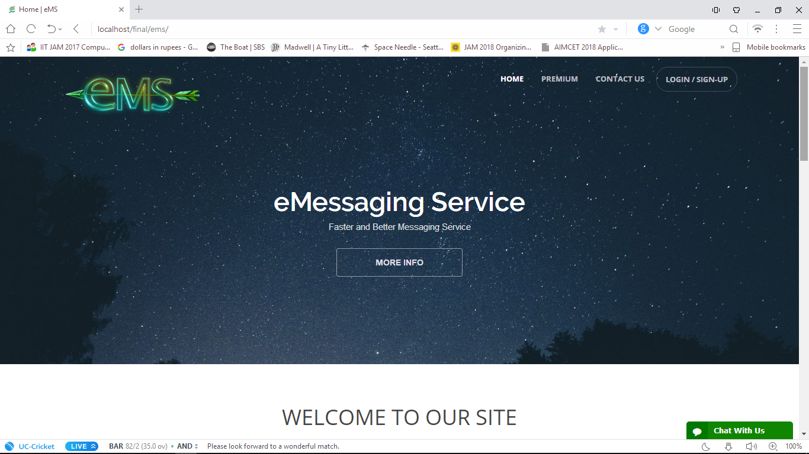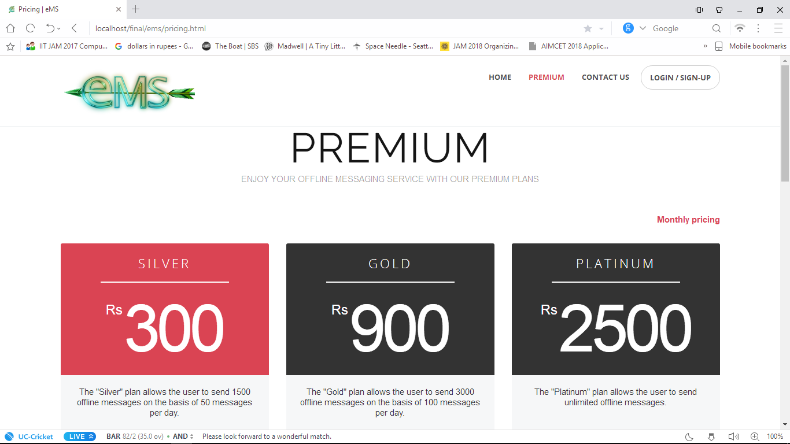

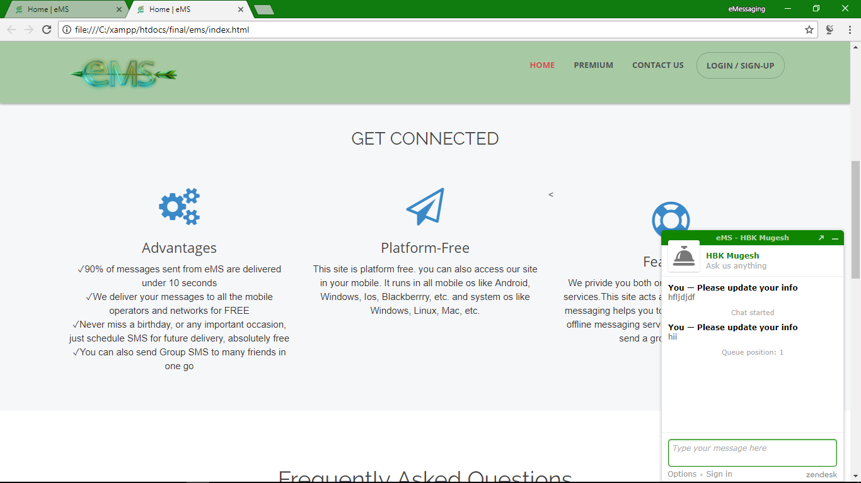

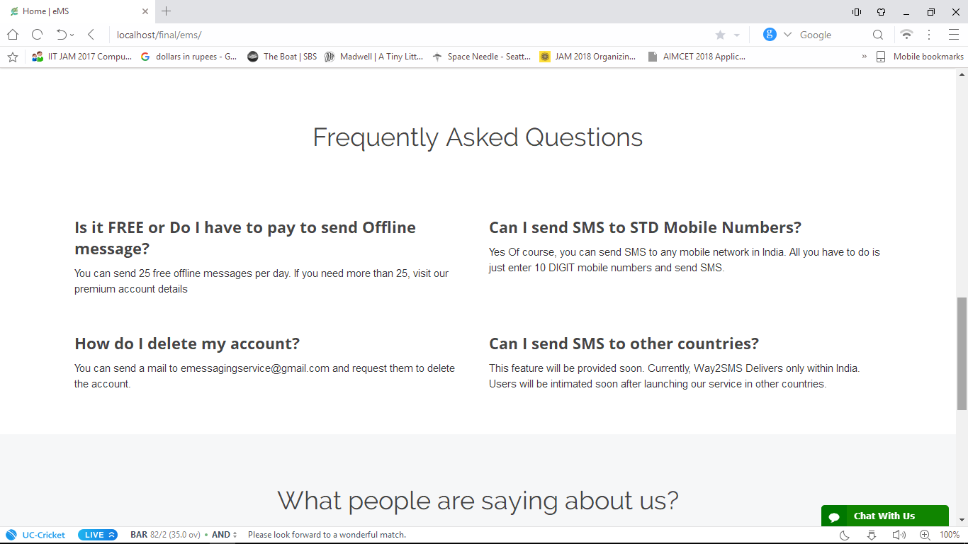

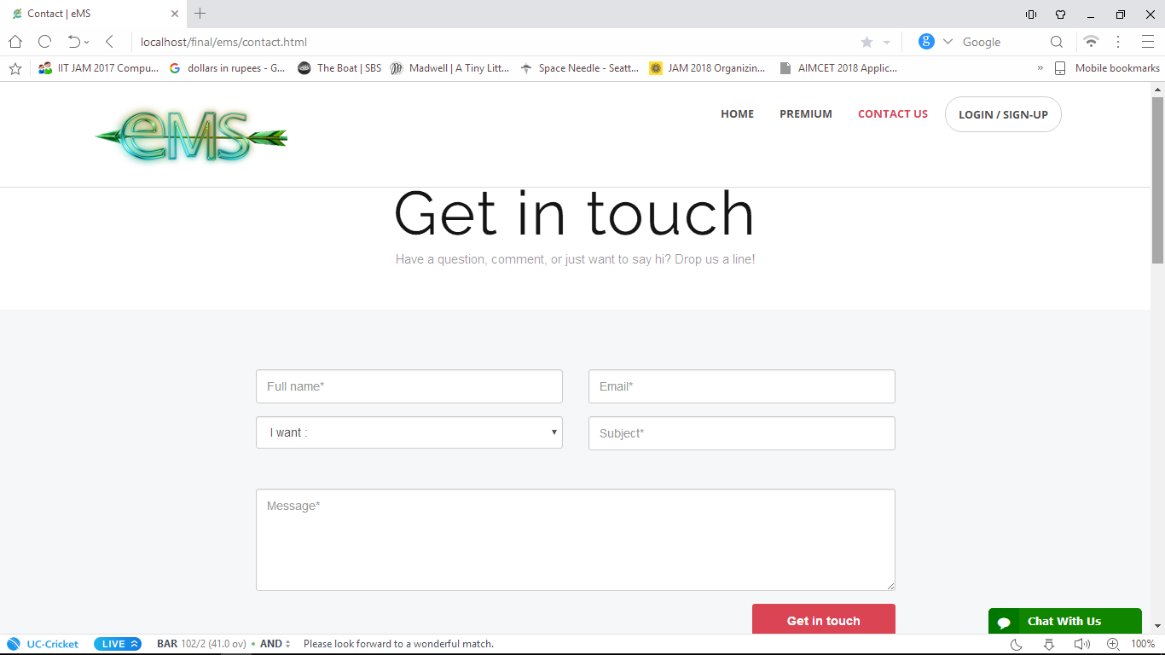

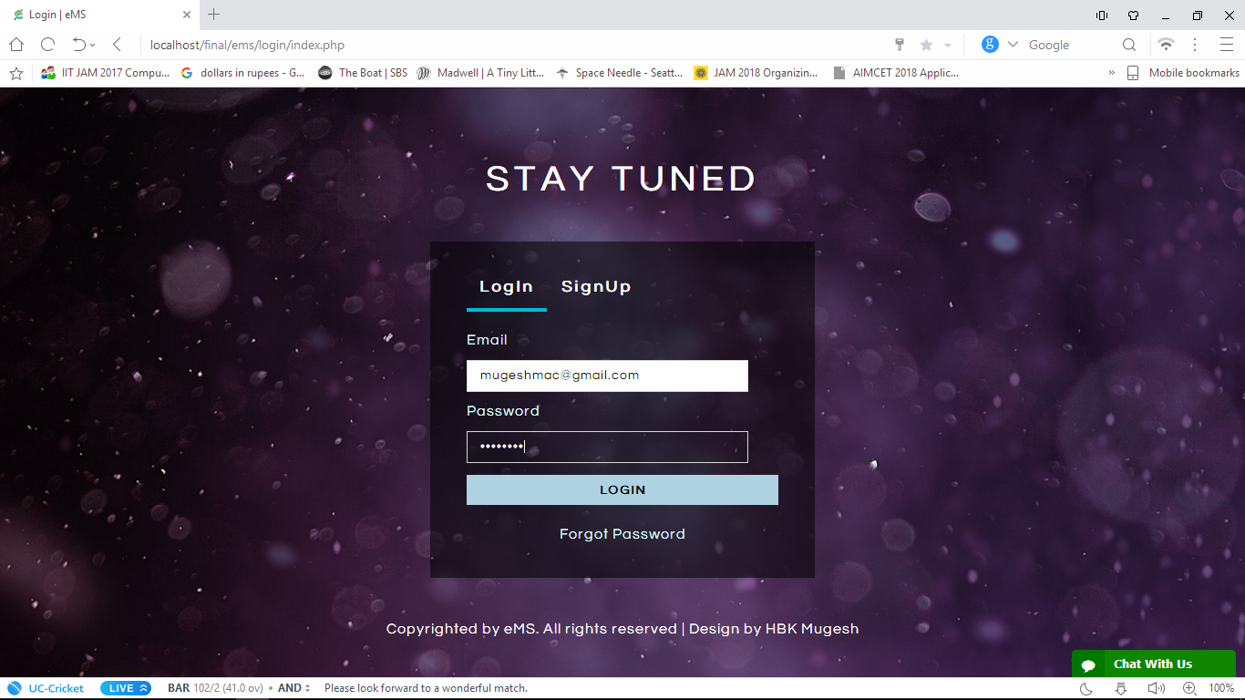

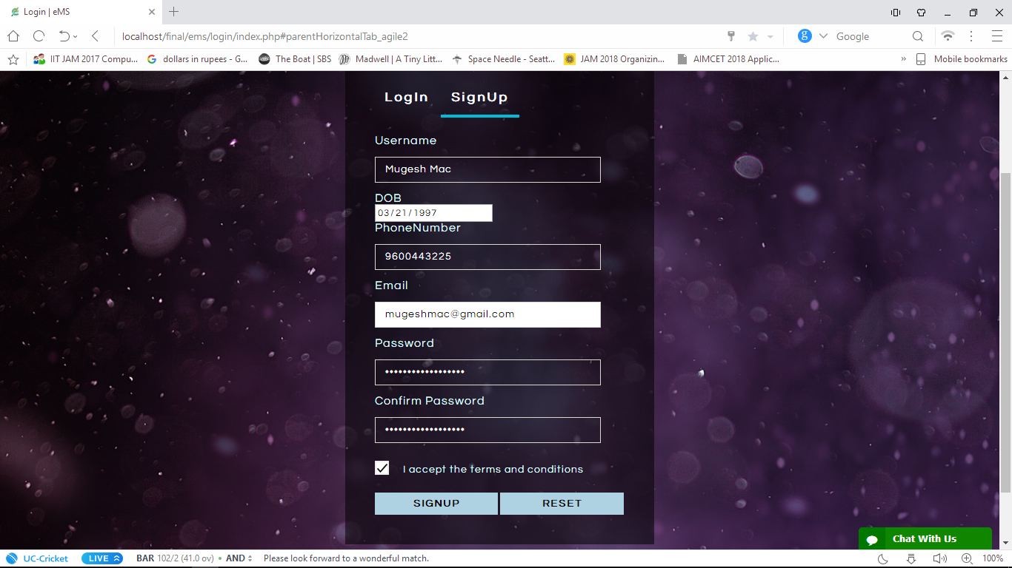

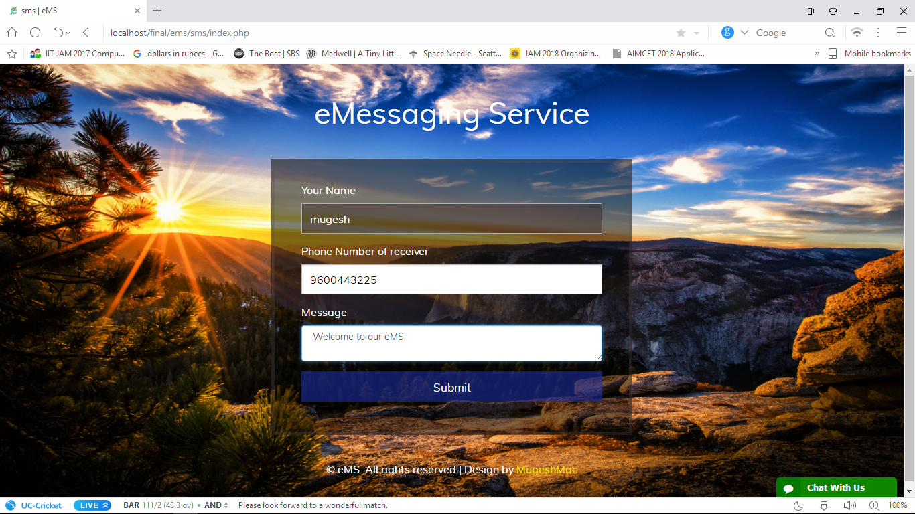

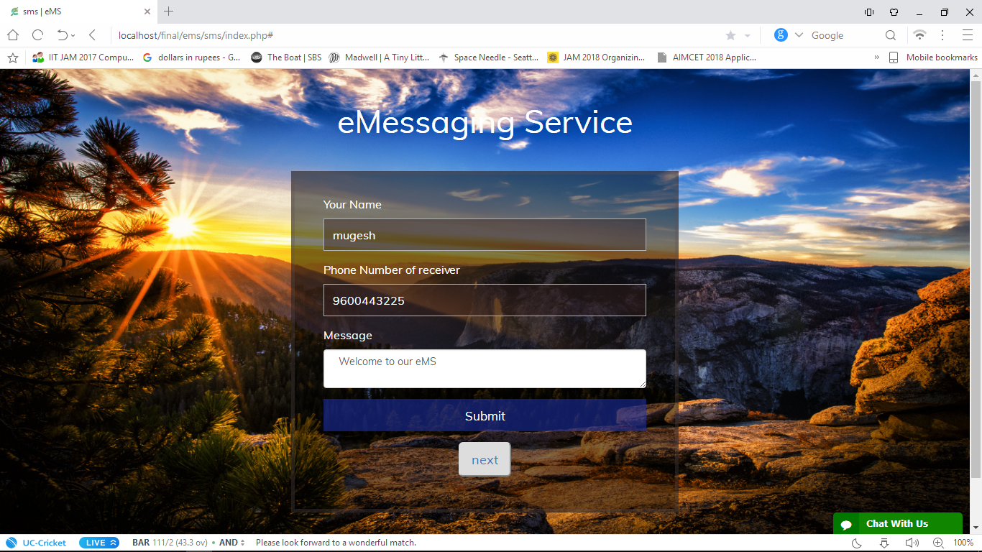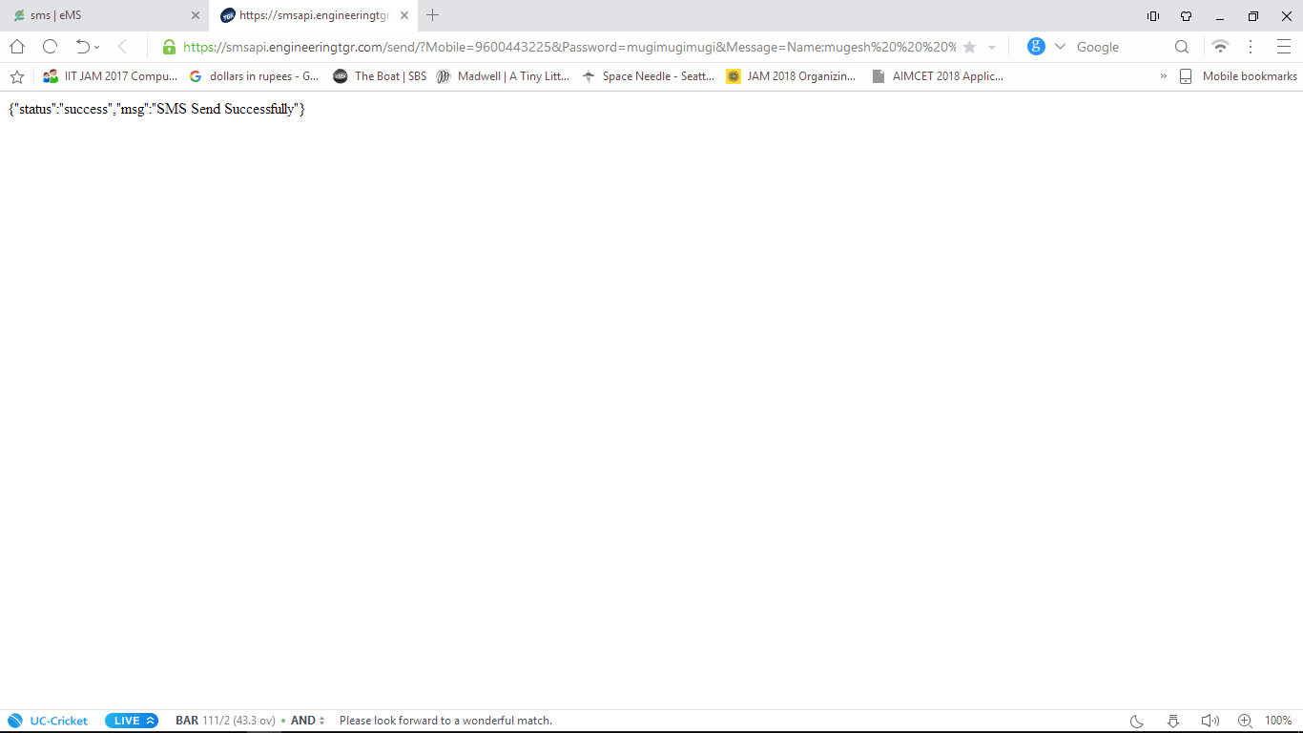

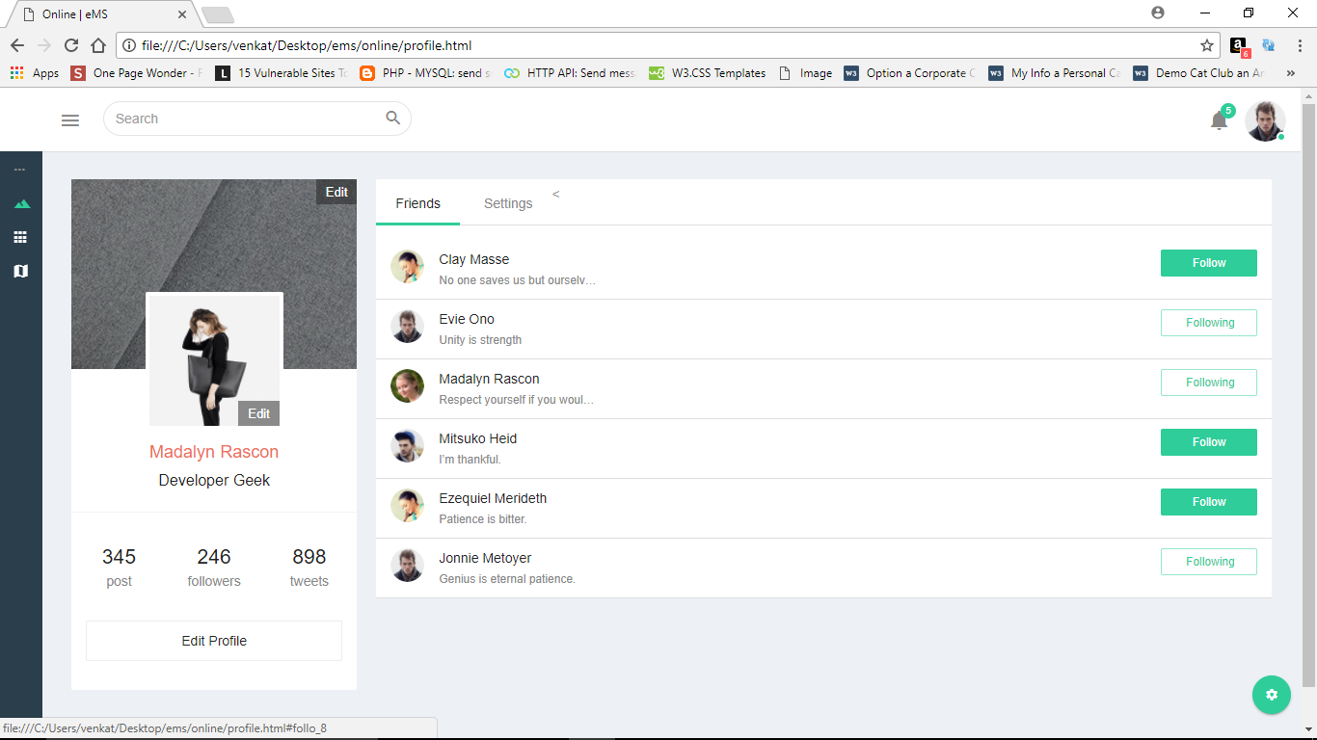

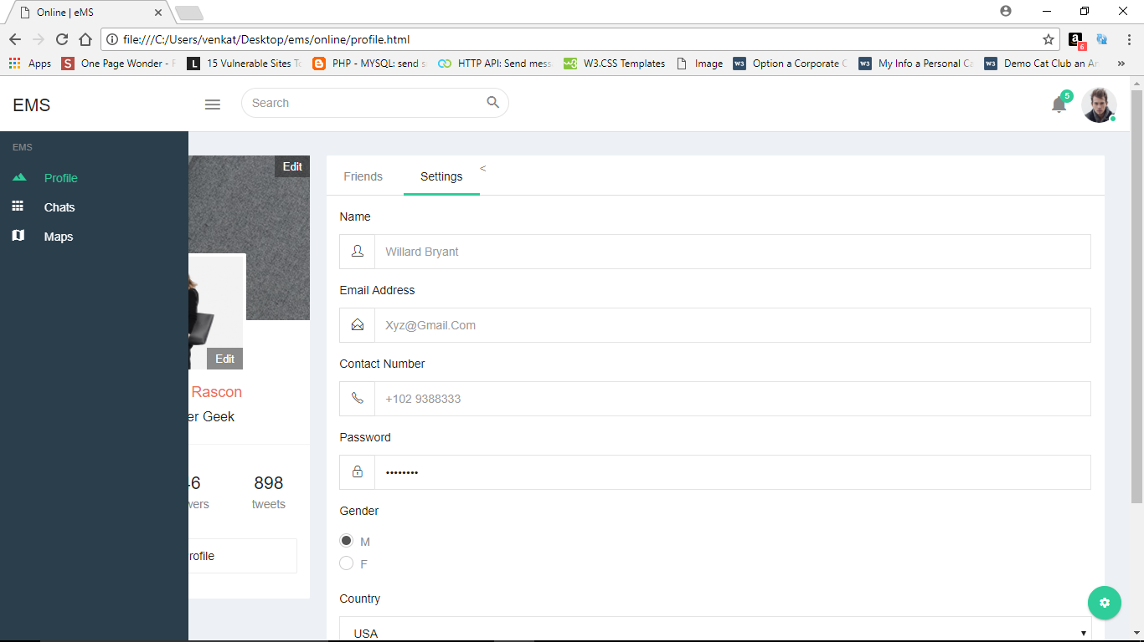

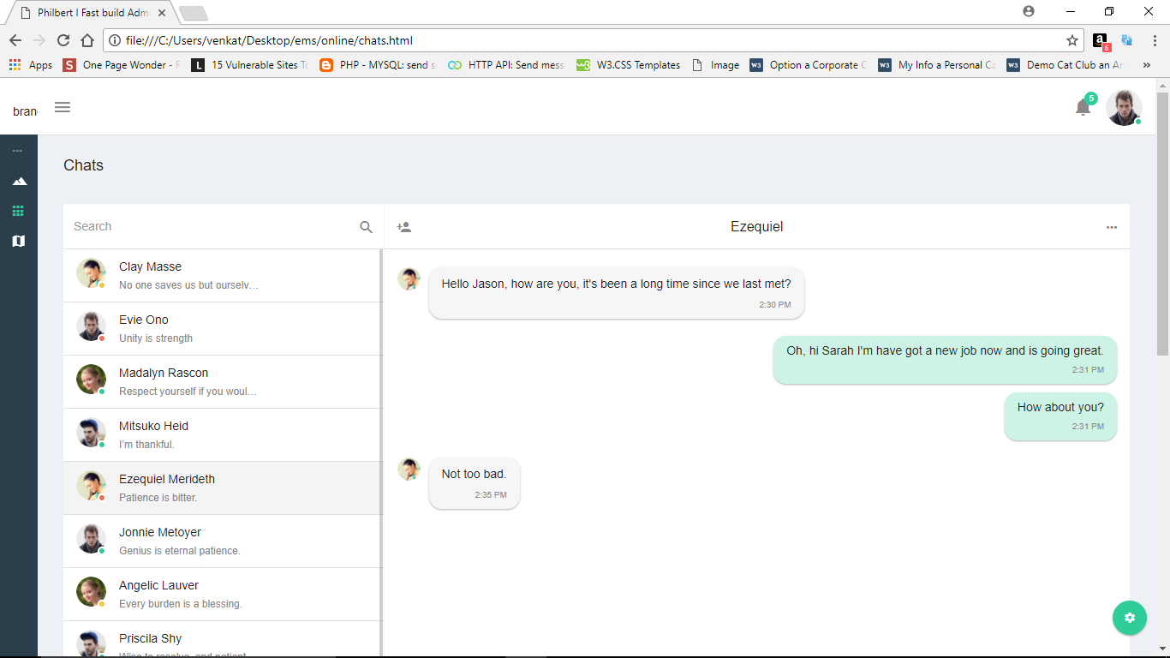

* 1. **SOURCE CODE**

**6.4.1 LOGIN**

**<? php**

**include once("../db. php");**

**if(isset($_POST['Login']))**

**{**

**$un=$_POST['username'];**

**$pass=$_POST['password'];**

**$query="SELECT * FROM login WHERE Email='$un' and Password='$pass' ";**

**$result=mysqli_query($db,$query);**

**$fetch=mysqli_fetch_array($result);**

**if(empty($fetch))**

**{**

**echo "<script>alert('Wrong Password');</script>";**

**}**

**else{**

**header("location:../selection.html");**

**}**

**}**

**if(isset($_POST['Sign-in']))**

**{**

**$un=$_POST['username'];**

**$pass=$_POST['password'];**

**$cpass=$_POST['cpassword'];**

**$dob=$_POST['date'];**

**$phone=$_POST['phone'];**

**$email=$_POST['email'];**

**$query="INSERT INTO login (Username,Password,DOB,Email,Phone) VALUES ('$un','$pass','$dob','$email','$phone')";**

**mysqli_query($db,$query);**

**}**

**?>**

**<html>**

**<head>**

**<title>Login | eMS</title>**

**<script type="application/x-javascript"> addEventListener("load", function() { setTimeout(hideURLbar, 0); }, false);**

**function hideURLbar(){ window.scrollTo(0,1); } </script>**

**<!-- //custom-theme -->**

**<link href="css/style.css" rel="stylesheet" type="text/css" media="all" />**

**<!-- js -->**

**<script src="js/jquery-1.9.1.min.js"></script>**

**<!--// js -->**

**<link rel="stylesheet" type="text/css" href="css/easy-responsive-tabs.css" />**

**<link href="http://fonts.googleapis.com/css?family=Questrial" rel="stylesheet">**

**<link rel="shortcut icon" href="../assets/images/page_icon.png">**

**<!--Start of Zendesk Chat Script-->**

**<script type="text/javascript">**

**window.$zopim||(function(d,s){var z=$zopim=function(c){z._.push(c)},$=z.s=**

**d.createElement(s),e=d.getElementsByTagName(s)[0];z.set=function(o){z.set.**

**_.push(o)};z._=[];z.set._=[];$.async=!0;$.setAttribute("charset","utf-8");**

**$.src="https://v2.zopim.com/?56JBM8crh8JqA6BJFUL5Ppum1Vmrhn6g";z.t=+new Date;$.**

**type="text/javascript";e.parentNode.insertBefore($,e)})(document,"script");**

**</script>**

**<!--End of Zendesk Chat Script-->**

**</head>**

**<body class="bg agileinfo">**

**<!--728x90-->**

**<h1 class="agile_head text-center"> Stay Tuned</h1>**

**<!--728x90-->**

**<div class="w3layouts_main wrap">**

**<!--Horizontal Tab-->**

**<div id="parentHorizontalTab_agile">**

**<ul class="resp-tabs-list hor_1">**

**<li>LogIn</li>**

**<li>SignUp</li>**

**</ul>**

**<div class="resp-tabs-container hor_1">**

**<div class="w3_agile_login">**

**<form action="" method="post" class="agile_form">**

**<p>Email</p>**

**<input type="email" name="username" required="required" />**

**<p>Password</p>**

**<input type="password" name="password" required="required" class="password" />**

**<input type="submit" value="LogIn" name="Login" class="agileinfo" />**

**</form>**

**<div class="login_w3ls">**

**<a href="#">Forgot Password</a>**

**</div>**

**</div>**

**<div class="agile_its_registration">**

**<form action="" method="post" class="agile_form">**

**<p>Username</p>**

**<input type="text" name="username" required="required" />**

**<p>DOB</p>**

**<input type="date" name="date" required="required" />**

**<p>PhoneNumber</p>**

**<input type="text" name="phone" required="required" pattern=".{10}" required title="plz enter a valid PhoneNumber"/>**

**<p>Email</p>**

**<input type="email" name="email" required="required" />**

**<p>Password</p>**

**<input type="password" name="password" id="password1" required="required" pattern=".{8,12}" required title="8 to 12 characters">**

**<p>Confirm Password</p>**

**<input type="password" name="cpassword" id="password2" required="required">**

**<div class="check w3_agileits">**

**<label class="checkbox w3"><input type="checkbox" name="checkbox" required="required" ><i> </i>I accept the terms and conditions</label>**

**</div>**

**<input type="submit" name="Sign-in" value="Signup"/>**

**<input type="reset" value="Reset" />**

**</form>**

**</div>**

**</div>**

**</div>**

**<!-- //Horizontal Tab -->**

**</div>**

**<!--728x90-->**

**<div class="agileits_w3layouts_copyright text-center">**

**<p>Copyrighted by eMS. All rights reserved | Design by <a href="https://facebook.com/mugeshmac/" target="_blank">HBK Mugesh</a></p>**

**</div>**

**<!--tabs-->**

**<script src="js/easyResponsiveTabs.js"></script>**

**<script type="text/javascript">**

**$(document).ready(function() {**

**//Horizontal Tab**

**$('#parentHorizontalTab_agile').easyResponsiveTabs({**

**type: 'default', //Types: default, vertical, accordion**

**width: 'auto', //auto or any width like 600px**

**fit: true, // 100% fit in a container**

**tabidentify: 'hor_1', // The tab groups identifier**

**activate: function(event) { // Callback function if tab is switched**

**var $tab = $(this);**

**var $info = $('#nested-tabInfo');**

**var $name = $('span', $info);**

**$name.text($tab.text());**

**$info.show();**

**}**

**});**

**});**

**</script>**

**<script type="text/javascript">**

**window.onload = function () {**

**document.getElementById("password1").onchange = validatePassword;**

**document.getElementById("password2").onchange = validatePassword;**

**}**

**function validatePassword(){**

**var pass2=document.getElementById("password2").value;**

**var pass1=document.getElementById("password1").value;**

**if(pass1!=pass2)**

**document.getElementById("password2").setCustomValidity("Passwords Don't Match");**

**else**

**document.getElementById("password2").setCustomValidity('');**

**//empty string means no validation error**

**}**

**</script>**

**<!--//tabs-->**

**</body>**

**</html>**

**6.4.2 OFFLINE MESSAGING**

**<?php**

**$name="";**

**$Phone="";**

**$Message="";**

**$i=0;**

**if(isset($_POST['submit']))**

**{**

**$name=$_POST['name'];**

**$Phone=$_POST['phone'];**

**$Message=$_POST['msg'];**

**$msg="Name:$name $Message";**

**//Admin Detais**

**$usernumber="9600443225";**

**$userpass="mugimugimugi";**

**$i=1;**

**}**

**?>**

**<html>**

**<head>**

**<title>sms | eMS</title>**

**<link href="//fonts.googleapis.com/css?family=Muli:300,400" rel="stylesheet">**

**<!-- /fonts -->**

**<!-- css -->**

**<link href="css/bootstrap.css" rel="stylesheet" type='text/css' media="all" />**

**<link href="css/style.css" rel="stylesheet" type='text/css' media="all" />**

**<!-- /css -->**

**<link rel="shortcut icon" href="../assets/images/page_icon.png">**

**<!--Start of Zendesk Chat Script-->**

**<script type="text/javascript">**

**window.$zopim||(function(d,s){var z=$zopim=function(c){z._.push(c)},$=z.s=**

**d.createElement(s),e=d.getElementsByTagName(s)[0];z.set=function(o){z.set.**

**_.push(o)};z._=[];z.set._=[];$.async=!0;$.setAttribute("charset","utf-8");**

**$.src="https://v2.zopim.com/?56JBM8crh8JqA6BJFUL5Ppum1Vmrhn6g";z.t=+new Date;$.**

**type="text/javascript";e.parentNode.insertBefore($,e)})(document,"script");**

**</script>**

**<!--End of Zendesk Chat Script-->**

**<body>**

**<h1 class="w3ls" data-text="eMessaging Service">eMessaging Service</h1>**

**<div class="content-agileits">**

**<form action="#" method="post" data-toggle="validator" role="form">**

**<div class="form-group w3layouts w3 w3l">**

**<label for="firstname" class="control-label">Your Name</label>**

**<input type="text" class="form-control" id="firstname" name="name" value="<?php echo "$name"; ?>" placeholder="Name" data-error="Enter Your Name" required>**

**<div class="help-block with-errors"></div>**

**</div>**

**<div class="form-group agileinfo wthree w3-agileits agile">**

**<label for="Phone" class="control-label">Phone Number of receiver</label>**

**<input type="text" class="form-control" id="Phone" name="phone" value="<?php echo "$Phone"; ?>" placeholder="Phone" data-error="Enter Your victem Phone Number" required>**

**<div class="help-block with-errors"></div>**

**</div>**

**<div class="form-group agileinfo wthree w3-agileits agile">**

**<label for="Phone" class="control-label">Message</label>**

**<textarea name="msg" class="form-control" id="Phone" placeholder="Your Message" data-error="Enter Your Message" required> <?php echo "$Message"; ?></textarea>**

**<div class="help-block with-errors"></div>**

**</div>**

**<div class="form-group" >**

**<button type="submit" name="submit" class="btn btn-lg">Submit</button>**

**</div>**

**</form>**

**<?php if($i==1): ?>**

**<div class="form-group" align="center">**

**<a target="_blank" href="http://smsapi.engineeringtgr.com/send/?Mobile=<?php echo $usernumber; ?>&Password=<?php echo $userpass; ?>&Message=<?php echo $msg; ?>&To=<?php echo $Phone; ?>" ><input type="submit" name="next" value="next" class="btn-lg"></a>**

**</div>**

**<?php endif; ?>**

**</div>**

**<!---728x90-->**

**<p class="copyright-w3ls">© eMS. All rights reserved | Design by <a href="https://facebook.com/mugeshmac/" target="_blank">MugeshMac</a></p>**

**<!-- js files -->**

**<script src="js/jquery-1.10.2.min.js"></script>**

**<script src="js/bootstrap.min.js"></script>**

**<script src="js/validator.min.js"></script>**

**<!-- /js files -->**

**</body>**

**</html>**

**6.4.3 SQL CONNECT**

**<?php**

**$db=mysqli_connect("localhost","root","","ems");**

**?>**

**6.2.4 ONLINE MESSAGING**

**<div class="page-wrapper">**

**<div class="container-fluid">**

**<!-- Title -->**

**<div class="row heading-bg">**

**<div class="col-lg-3 col-md-4 col-sm-4 col-xs-12">**

**<h5 class="txt-dark">chats</h5>**

**</div>**

**</div>**

**<!-- /Title -->**

**<!-- Row -->**

**<div class="row">**

**<div class="col-md-12">**

**<div class="panel panel-default border-panel card-view pa-0">**

**<div class="panel-wrapper collapse in">**

**<div class="panel-body pa-0">**

**<div class="chat-cmplt-wrap chat-for-widgets-1">**

**<div class="chat-box-wrap">**

**<div>**

**<form role="search" class="chat-search">**

**<div class="input-group">**

**<input id="example-input1-group21" name="example-input1-group2" class="form-control" placeholder="Search" type="text">**

**<span class="input-group-btn">**

**<button type="button" class="btn btn-default"><i class="zmdi zmdi-search"></i></button>**

**</span>**

**</div>**

**</form>**

**<div class="chatapp-nicescroll-bar">**

**<ul class="chat-list-wrap">**

**<li class="chat-list">**

**<div class="chat-body">**

**<a href="javascript:void(0)">**

**<div class="chat-data">**

**<img class="user-img img-circle" src="dist/img/user.png" alt="user"/>**

**<div class="user-data">**

**<span class="name block capitalize-font">Clay Masse</span>**

**<span class="time block truncate txt-grey">No one saves us but ourselves.</span>**

**</div>**

**<div class="status away"></div>**

**<div class="clearfix"></div>**

**</div>**

**</a>**

**<a href="javascript:void(0)">**

**<div class="chat-data">**

**<img class="user-img img-circle" src="dist/img/user1.png" alt="user"/>**

**<div class="user-data">**

**<span class="name block capitalize-font">Evie Ono</span>**

**<span class="time block truncate txt-grey">Unity is strength</span>**

**</div>**

**<div class="status offline"></div>**

**<div class="clearfix"></div>**

**</div>**

**</a>**

**<a href="javascript:void(0)">**

**<div class="chat-data">**

**<img class="user-img img-circle" src="dist/img/user2.png" alt="user"/>**

**<div class="user-data">**

**<span class="name block capitalize-font">Madalyn Rascon</span>**

**<span class="time block truncate txt-grey">Respect yourself if you would have others respect you.</span>**

**</div>**

**<div class="status online"></div>**

**<div class="clearfix"></div>**

**</div>**

**</a>**

**<a href="javascript:void(0)">**

**<div class="chat-data">**

**<img class="user-img img-circle" src="dist/img/user3.png" alt="user"/>**

**<div class="user-data">**

**<span class="name block capitalize-font">Mitsuko Heid</span>**

**<span class="time block truncate txt-grey">I’m thankful.</span>**

**</div>**

**<div class="status online"></div>**

**<div class="clearfix"></div>**

**</div>**

**</a>**

**<a href="javascript:void(0)">**

**<div class="chat-data active-user">**

**<img class="user-img img-circle" src="dist/img/user.png" alt="user"/>**

**<div class="user-data">**

**<span class="name block capitalize-font">Ezequiel Merideth</span>**

**<span class="time block truncate txt-grey">Patience is bitter.</span>**

**</div>**

**<div class="status offline"></div>**

**<div class="clearfix"></div>**

**</div>**

**</a>**

**<a href="javascript:void(0)">**

**<div class="chat-data">**

**<img class="user-img img-circle" src="dist/img/user1.png" alt="user"/>**

**<div class="user-data">**

**<span class="name block capitalize-font">Jonnie Metoyer</span>**

**<span class="time block truncate txt-grey">Genius is eternal patience.</span>**

**</div>**

**<div class="status online"></div>**

**<div class="clearfix"></div>**

**</div>**

**</a>**

**<a href="javascript:void(0)">**

**<div class="chat-data">**

**<img class="user-img img-circle" src="dist/img/user2.png" alt="user"/>**

**<div class="user-data">**

**<span class="name block capitalize-font">Angelic Lauver</span>**

**<span class="time block truncate txt-grey">Every burden is a blessing.</span>**

**</div>**

**<div class="status away"></div>**

**<div class="clearfix"></div>**

**</div>**

**</a>**

**<a href="javascript:void(0)">**

**<div class="chat-data">**

**<img class="user-img img-circle" src="dist/img/user3.png" alt="user"/>**

**<div class="user-data">**

**<span class="name block capitalize-font">Priscila Shy</span>**

**<span class="time block truncate txt-grey">Wise to resolve, and patient to perform.</span>**

**</div>**

**<div class="status online"></div>**

**<div class="clearfix"></div>**

**</div>**

**</a>**

**<a href="javascript:void(0)">**

**<div class="chat-data">**

**<img class="user-img img-circle" src="dist/img/user4.png" alt="user"/>**

**<div class="user-data">**

**<span class="name block capitalize-font">Linda Stack</span>**

**<span class="time block truncate txt-grey">Our patience will achieve more than our force.</span>**

**</div>**

**<div class="status away"></div>**

**<div class="clearfix"></div>**

**</div>**

**</a>**

**</div>**

**</li>**

**</ul>**

**</div>**

**</div>**

**</div>**

**<div class="recent-chat-box-wrap">**

**<div class="recent-chat-wrap">**

**<div class="panel-heading ma-0 pt-15">**

**<div class="goto-back">**

**<a id="goto_back_widget_1" href="javascript:void(0)" class="inline-block txt-grey">**

**<i class="zmdi zmdi-account-add"></i>**

**</a>**

**<span class="inline-block txt-dark">Ezequiel</span>**

**<a href="javascript:void(0)" class="inline-block text-right txt-grey"><i class="zmdi zmdi-more"></i></a>**

**<div class="clearfix"></div>**

**</div>**

**</div>**

**<div class="panel-wrapper collapse in">**

**<div class="panel-body pa-0">**

**<div class="chat-content">**

**<ul class="chatapp-chat-nicescroll-bar pt-20">**

**<li class="friend">**

**<div class="friend-msg-wrap">**

**<img class="user-img img-circle block pull-left" src="dist/img/user.png" alt="user"/>**

**<div class="msg pull-left">**

**<p>Hello Jason, how are you, it's been a long time since we last met?</p>**

**<div class="msg-per-detail text-right">**

**<span class="msg-time txt-grey">2:30 PM</span>**

**</div>**

**</div>**

**<div class="clearfix"></div>**

**</div>**

**</li>**

**<li class="self mb-10">**

**<div class="self-msg-wrap">**

**<div class="msg block pull-right"> Oh, hi Sarah I'm have got a new job now and is going great.**

**<div class="msg-per-detail text-right">**

**<span class="msg-time txt-grey">2:31 pm</span>**

**</div>**

**</div>**

**<div class="clearfix"></div>**

**</div>**

**</li>**

**<li class="self">**

**<div class="self-msg-wrap">**

**<div class="msg block pull-right"> How about you?**

**<div class="msg-per-detail text-right">**

**<span class="msg-time txt-grey">2:31 pm</span>**

**</div>**

**</div>**

**<div class="clearfix"></div>**

**</div>**

**</li>**

**<li class="friend">**

**<div class="friend-msg-wrap">**

**<img class="user-img img-circle block pull-left" src="dist/img/user.png" alt="user"/>**

**<div class="msg pull-left">**

**<p>Not too bad.</p>**

**<div class="msg-per-detail text-right">**

**<span class="msg-time txt-grey">2:35 pm</span>**

**</div>**

**</div>**

**<div class="clearfix"></div>**

**</div>**

**</li>**

**</ul>**

**</div>**

**<div class="input-group">**

**<input type="text" id="input_msg_send_chatapp" name="send-msg" class="input-msg-send form-control" placeholder="Type something">**

**<div class="input-group-btn emojis">**

**<div class="dropup">**

**<button type="button" class="btn btn-default dropdown-toggle" data-toggle="dropdown" ><i class="zmdi zmdi-mood"></i></button>**

**<ul class="dropdown-menu dropdown-menu-right">**

**<li><a href="javascript:void(0)">Action</a></li>**

**<li><a href="javascript:void(0)">Another action</a></li>**

**<li class="divider"></li>**

**<li><a href="javascript:void(0)">Separated link</a></li>**

**</ul>**

**</div>**

**</div>**

**<div class="input-group-btn attachment">**

**<div class="fileupload btn btn-default"><i class="zmdi zmdi-attachment-alt"></i>**

**<input type="file" class="upload">**

**</div>**

**</div>**

**</div>**

**</div>**

**</div>**

**</div>**

**</div>**

**</div>**

**</div>**

**</div>**

**</div>**

**</div>**

**</div>**

**<!-- /Row -->**

**<!-- Row -->**

**<div class="row">**

**<div class="col-md-12">**

**<div class="panel panel-default card-view panel-refresh">**

**<div class="refresh-container">**

**<div class="la-anim-1"></div>**

**</div>**

**<div class="panel-heading">**

**<div class="pull-left">**

**<h6 class="panel-title txt-dark">chat history</h6>**

**</div>**

**<div class="pull-right">**

**<a href="#" class="pull-left inline-block refresh">**

**<i class="zmdi zmdi-replay"></i>**

**</a>**

**</div>**

**<div class="clearfix"></div>**

**</div>**

**<div class="panel-wrapper collapse in">**

**<div class="panel-body pa-0 row">**

**<div class="mail-box chat-history">**

**<div class="row">**

**<aside class="col-md-12">**

**<div class="inbox-body">**

**<div class="mail-option pl-15 pr-15">**

**<div class="chk-all">**

**<div class="checkbox checkbox-default inline-block">**

**<input type="checkbox" id="checkbox051"/>**

**<label for="checkbox051"></label>**

**</div>**

**<div class="btn-group">**

**<a data-toggle="dropdown" href="#" class="btn all" aria-expanded="false">**

**All**

**<i class="fa fa-angle-down "></i>**

**</a>**

**<ul class="dropdown-menu">**

**<li><a href="#"> None</a></li>**

**<li><a href="#"> Read</a></li>**

**<li><a href="#"> Unread</a></li>**

**</ul>**

**</div>**

**<div class="btn-group">**

**<a data-toggle="dropdown" href="#" class="btn blue" aria-expanded="false">**

**More**

**<i class="fa fa-angle-down "></i>**

**</a>**

**<ul class="dropdown-menu">**

**<li><a href="#"><i class="fa fa-pencil"></i> Mark as Read</a></li>**

**<li><a href="#"><i class="fa fa-ban"></i> Spam</a></li>**

**<li class="divider"></li>**

**<li><a href="#"><i class="fa fa-trash-o"></i> Delete</a></li>**

**</ul>**

**</div>**

**</div>**

**<ul class="unstyled inbox-pagination">**

**<li><span>1-10 of 234</span></li>**

**<li>**

**<a class="pl-15 pr-15" href="#"><i class="fa fa-angle-left pagination-left"></i></a>**

**</li>**

**<li>**

**<a href="#"><i class="fa fa-angle-right pagination-right"></i></a>**

**</li>**

**</ul>**

**</div>**

**<div class="table-responsive">**

**<table class="table table-inbox table-hover mb-0">**

**<tbody>**

**<tr class="unread">**

**<td class="inbox-small-cells">**

**<div class="checkbox checkbox-default inline-block">**

**<input type="checkbox" id="checkbox012"/>**

**<label for="checkbox012"></label>**

**</div>**

**<i class="zmdi zmdi-star inline-block font-16"></i>**

**</td>**

**<td class="view-message dont-show">Clay Masse</td>**

**<td class="view-message ">Added a new class: Login Class Fast Site</td>**

**<td class="view-message text-right">**

**<i class="zmdi zmdi-quote inline-block mr-15 font-16"></i>**

**<span class="time-chat-history inline-block">9:27 AM</span>**

**</td>**

**</tr>**

**<tr class="unread">**

**<td class="inbox-small-cells">**

**<div class="checkbox checkbox-default inline-block">**

**<input type="checkbox" id="checkbox013"/>**

**<label for="checkbox013"></label>**

**</div>**

**<i class="zmdi zmdi-star inline-block font-16"></i>**

**</td>**

**<td class="view-message dont-show">Evie Ono</td>**

**<td class="view-message">Improve the search presence of WebSite</td>**

**<td class="view-message text-right">**

**<i class="zmdi zmdi-quote inline-block mr-15 font-16"></i>**

**<span class="time-chat-history inline-block">April 01</span>**

**</td>**

**</tr>**

**<tr class="">**

**<td class="inbox-small-cells">**

**<div class="checkbox checkbox-default inline-block">**

**<input type="checkbox" id="checkbox014"/>**

**<label for="checkbox014"></label>**

**</div>**

**<i class="zmdi zmdi-star inline-block font-16"></i>**

**</td>**

**<td class="view-message dont-show">Madalyn Rascon</td>**

**<td class="view-message">Last Chance: Upgrade to Pro for </td>**

**<td class="view-message text-right">**

**<i class="zmdi zmdi-quote inline-block mr-15 font-16"></i>**

**<span class="time-chat-history inline-block">March 15</span>**

**</td>**

**</tr>**

**<tr class="">**

**<td class="inbox-small-cells">**

**<div class="checkbox checkbox-default inline-block">**

**<input type="checkbox" id="checkbox015"/>**

**<label for="checkbox015"></label>**

**</div>**

**<i class="zmdi zmdi-star inline-block font-16"></i>**

**</td>**

**<td class="view-message dont-show">Mitsuko Heid</td>**

**<td class="view-message">Boost Your Website Traffic</td>**

**<td class="view-message text-right">**

**<i class="zmdi zmdi-quote inline-block mr-15 font-16"></i>**

**<span class="time-chat-history inline-block">April 01</span>**

**</td>**

**</tr>**

**<tr class="">**

**<td class="inbox-small-cells">**

**<div class="checkbox checkbox-default inline-block">**

**<input type="checkbox" id="checkbox016"/>**

**<label for="checkbox016"></label>**

**</div>**

**<i class="zmdi zmdi-star inline-block font-16"></i>**

**</td>**

**<td class="view-message dont-show">Ezequiel Merideth</td>**

**<td class="view-message">Stop wasting your visitors </td>**

**<td class="view-message text-right">**

**<i class="zmdi zmdi-quote inline-block mr-15 font-16"></i>**

**<span class="time-chat-history inline-block">March 01</span>**

**</td>**

**</tr>**

**<tr class="">**

**<td class="inbox-small-cells">**

**<div class="checkbox checkbox-default inline-block">**

**<input type="checkbox" id="checkbox0016"/>**

**<label for="checkbox0016"></label>**

**</div>**

**<i class="zmdi zmdi-star inline-block font-16"></i>**

**</td>**

**<td class="view-message dont-show">Jonnie Madalyn </td>**

**<td class="view-message">New WOW Slider v7.8 - 67% off</td>**

**<td class="view-message text-right">**

**<i class="zmdi zmdi-quote inline-block mr-15 font-16"></i>**

**<span class="time-chat-history inline-block">March 14</span>**

**</td>**

**</tr>**

**<tr class="unread">**

**<td class="inbox-small-cells">**

**<div class="checkbox checkbox-default inline-block">**

**<input type="checkbox" id="checkbox018"/>**

**<label for="checkbox018"></label>**

**</div>**

**<i class="zmdi zmdi-star inline-block font-16"></i>**

**</td>**

**<td class="view-message dont-show">Angelic Lauver</td>**

**<td class="view-message">The One Sign Your Co-Worker Will Stab</td>**

**<td class="view-message text-right">**

**<i class="zmdi zmdi-quote inline-block mr-15 font-16"></i>**

**<span class="time-chat-history inline-block">Feb 19</span>**

**</td>**

**</tr>**

**<tr class="unread">**

**<td class="inbox-small-cells">**

**<div class="checkbox checkbox-default inline-block">**

**<input type="checkbox" id="checkbox019"/>**

**<label for="checkbox019"></label>**

**</div>**

**<i class="zmdi zmdi-star inline-block font-16"></i>**

**</td>**

**<td class="view-message dont-show">Priscila Shy</td>**

**<td class="view-message view-message">Welcome to the Drupal Community</td>**

**<td class="view-message text-right">**

**<i class="zmdi zmdi-quote inline-block mr-15 font-16"></i>**

**<span class="time-chat-history inline-block">March 04</span>**

**</td>**

**</tr>**

**<tr class="">**

**<td class="inbox-small-cells">**

**<div class="checkbox checkbox-default inline-block">**

**<input type="checkbox" id="checkbox022"/>**

**<label for="checkbox022"></label>**

**</div>**

**<i class="zmdi zmdi-star inline-block font-16"></i>**

**</td>**

**<td class="view-message dont-show">Linda Stack</td>**

**<td class="view-message view-message">Somebody requested a new password </td>**

**<td class="view-message text-right">**

**<i class="zmdi zmdi-quote inline-block mr-15 font-16"></i>**

**<span class="time-chat-history inline-block">June 13</span>**

**</td>**

**</tr>**

**<tr class="">**

**<td class="inbox-small-cells">**

**<div class="checkbox checkbox-default inline-block">**

**<input type="checkbox" id="checkbox032"/>**

**<label for="checkbox032"></label>**

**</div>**

**<i class="zmdi zmdi-star inline-block font-16"></i>**

**</td>**

**<td class="view-message dont-show">John Doe</td>**

**<td class="view-message view-message">Password successfully changed</td>**

**<td class="view-message text-right">**

**<i class="zmdi zmdi-quote inline-block mr-15 font-16"></i>**

**<span class="time-chat-history inline-block">April 01</span>**

**</td>**

**</tr>**

**</tbody>**

**</table>**

**</div>**

**</div>**

**</aside>**

**</div>**

**</div>**

**</div>**

**</div>**

**</div>**

**</div>**

**</div>**

**</div>**

**<!-- Footer -->**

**<footer class="footer container-fluid pl-30 pr-30">**

**<div class="row">**

**<div class="col-sm-12">**

**<p>2017 &copy; Philbert. Pampered by Hencework</p>**

**</div>**

**</div>**

**</footer>**

**<!-- /Footer -->**

**</div>**

**CONCLUSION & FUTURE ENHANCEMENT**

**7. CONCLUSION AND FUTURE ENHANCEMENT**

The main purpose of the software package “Electronic Messaging System” is to provide a free messaging service to the people. This helps the people to get in touch with their friends. This system also helps an organization to send free messages to their employees.

This package is designed and developed in a compact manner, which is ready to meet the users specification and to serve them in an effective as well as in an enhanced manner. The actual problem has been observed with keen interest and it has been defined and analyzed in such a way that it never causes choice to the user

Most features are still in a development process. We are to add few special features like sending offline group messaging service, time limit and payment methods for the premium account, and other few small features.

**BIBLIOGRAPHY**

**8. BIBLIOGRAPHY**

**REFERENCE**

1. “[PHP Objects, Patterns, and Practice](https://www.goodreads.com/book/show/1569843.PHP_Objects_Patterns_and_Practice)”- Matt Zandstra

2. “[PHP and MySQL Web Development](https://www.goodreads.com/book/show/40540.PHP_and_MySQL_Web_Development)” – Luke Welling

3. “Head First PHP & MySQL: A Brain-Friendly Guide” -Lynn Beighely

4. “The Truth About HTML5” -Luke Stevens

5. “The Essential Guide to CSS and HTML Web Design” -Craig Grannell

**Sites Referred**

http://www.phptherightway.com/

https://www.tutorialspoint.com/

http://www.tutorialized.com/tutorials/MySQL/1

https://www.w3schools.com/html/

https://www.w3schools.com/php/